
ATAR Biology

Unit 1: Topic 4 Succession

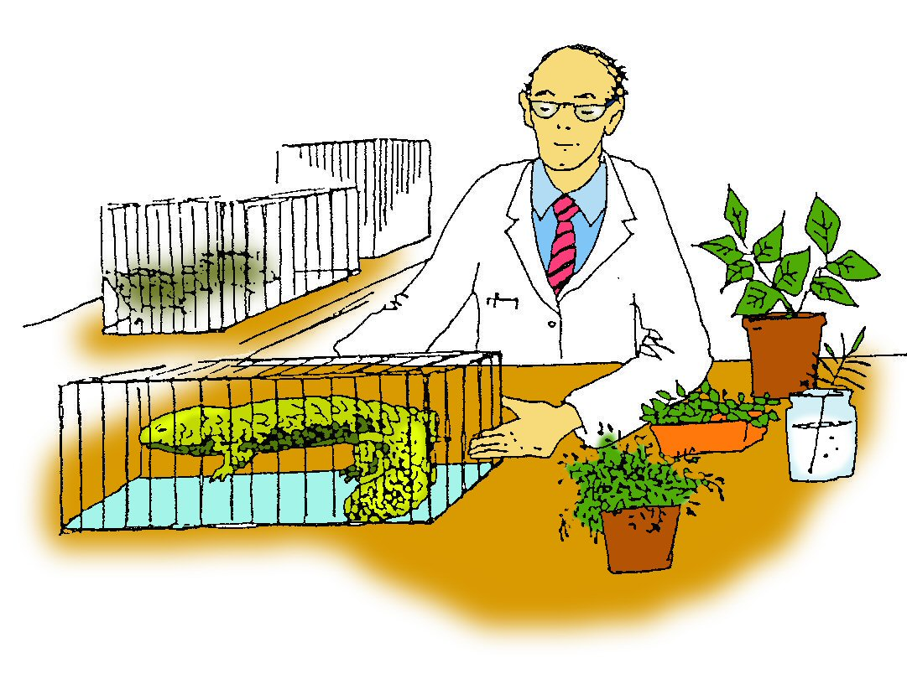

Student Study Notes

Unit Content
- Ecological succession involves changes in the populations of species present in a habitat; these changes impact the abiotic and biotic interactions in the community, which in turn influence further changes in the species present and their population size.
- Fire is a dynamic factor in Australian ecosystems and has different effects on biodiversity.
- Models of ecosystem interactions (food webs, successional models) can be used to predict the impact of change and are based on interpretation of and extrapolation from sample data (data derived from ecosystem surveying techniques); the reliability of the model is determined by the representativeness of the sampling.

Ecological succession

Ecological succession is a process of change in a community with time.

Primary succession

Primary succession is the colonisation of plant life in a bare site.

An area with no vegetation or soil, such as coastal sand dunes may be colonized by pioneer plants. Working back from the water, plant root systems are more extensive and shallow, therefore acting as soil binders. Insects and other small animals are found mainly in the stable dunes further inland.

Transect profile of sand dunes

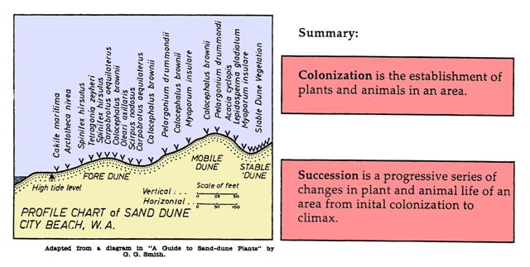

Secondary succession

Secondary succession is the recolonisation of plant life in a recently disturbed area.

If an established area is destroyed by fire, or other natural disasters it may undergo secondary succession. If root systems are undamaged recovery is usually over short period of time.

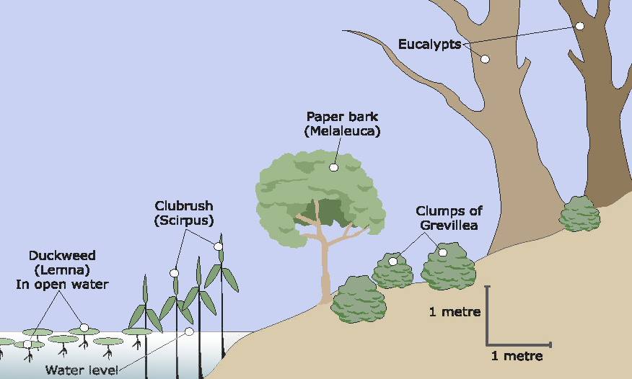

Fire
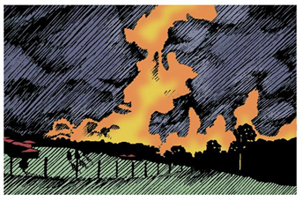
Intense bushfires are a threat to biodiversity because they destroy habitats, kill many animals and plants, generate huge clouds of smoke and release carbon dioxide into the atmosphere. Fire-fighters use prescribed burning to reduce the chance of a major bushfire occurring.

Consequences
Fire has been a natural part of most Australian Ecosystems.
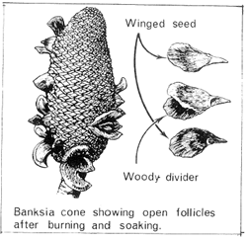
Some positive biological consequences of fire in ecosystems include:
- The heat released from fires causes the release of seeds from many Australian plants including eucalypts.
- The fire causes the release of ethylene gas which stimulates flowering in many plants.
- The smoke from fire stimulates many dormant seeds to germinate.
- Nutrients released in the ash stimulate many plants to flourish
- A reduction in the fuel load to reduce the chance of a major bushfire occurring.

PRACTICE QUESTIONS:

1. Other than sand dunes, suggest two areas where primary succession could take place.

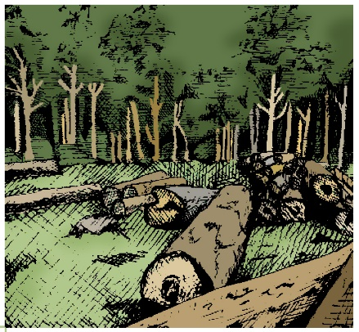

2. Secondary succession may take place when a tree falls in a rainforest as light reaches the ground from the gap in the canopy. Suggest why selective logging may have less impact on a rainforest community than the clearing of trees over a large area.

Source: EdWest Sem1 2017
3. The image below represents a woodland community located in the south-west of Western Australia.
It is a community that has been established over a period of fifty years on what was once
grazing pasture land for cows and sheep.
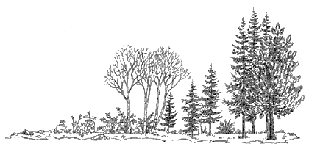

- Explain how ecological succession could have produced this community.

Recent summer seasons in the south-west of Western Australia have been very hot and dry. There have been a number of large scale fires that burnt through bushland and farmland.

- For each of the following features, describe the effect of a fire passing through this woodland community.
(i) Biomass _________________________________

(i) Germination rates (native species) _________________________________

(iii) Soil nutrients _________________________________

(iv) Biodiversity _________________________________

Source: Academic Task Force Sem1 2019
4. Fire is a dynamic factor in Australian ecosystems. Fire also has a variety of effects on biodiversity. Identify three (3) ways that fire is beneficial and three (3) ways that fire is detrimental to components of Australian ecosystems.

Practice Extended Response
5. Describe the process of primary ecological succession. Explain how the process differs from secondary ecological succession. Use examples to support your discussion.

